Day 2

1)

(i)Use cov() to calculate the sample covariance between B and C.

(ii)Use another call to cov() to calculate the sample covariance matrix for the preferences.

(iii)Use cor() to calculate the sample correlation between B and C.

(iv)Use another call to cor() to calculate the sample correlation matrix for the preferences.

**SOL:**

> A=c(18,2,20)

> B=c(22,28,10)

> C=c(20,40,40)

> r=data.frame(A,B,C)

> r

A B C

1 18 22 20

2 2 28 40

3 20 10 40

> cov(r)

A B C

A 97.33333 -74 -46.66667

B -74.00000 84 -20.00000

C -46.66667 -20 133.33333

> cor(B,C)

[1] -0.1889822

> cor(r)

A B C

A 1.0000000 -0.8183918 -0.4096440

B -0.8183918 1.0000000 -0.1889822

C -0.4096440 -0.1889822 1.0000000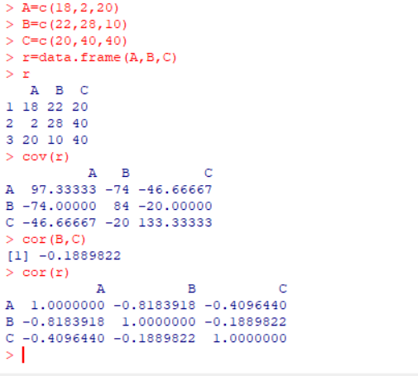

2.

(i)Bin equals to 3

(ii)Mean

(iii)Histogram of Bins

> o=c(1,1,5,5,5,5,5,8,8,10,10,10,12,14)

> g=c(20,20,20,20,21,21,21,21,25,25,25,25,25,28,28,30)

> p=c(14,14,15,15,15,15,15,15,18,18,18,18,18,20,20)

> mean(o)

[1] 7.071429

> mean(p)

[1] 16.53333

> mean(g)

[1] 23.4375

> hist(o)

> hist(p)

> hist(g)

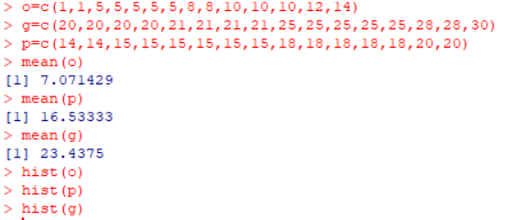

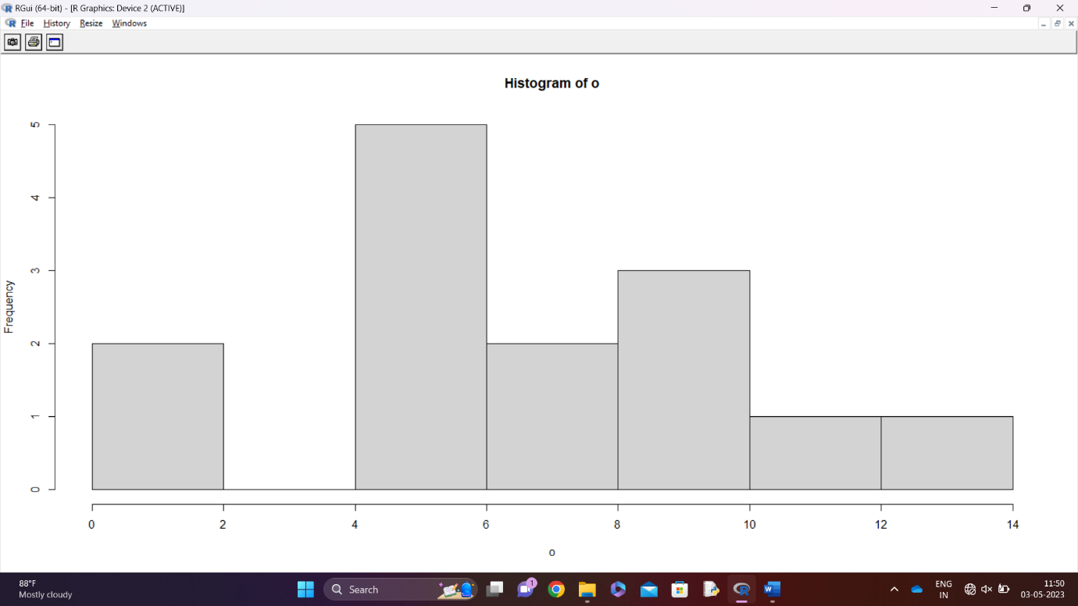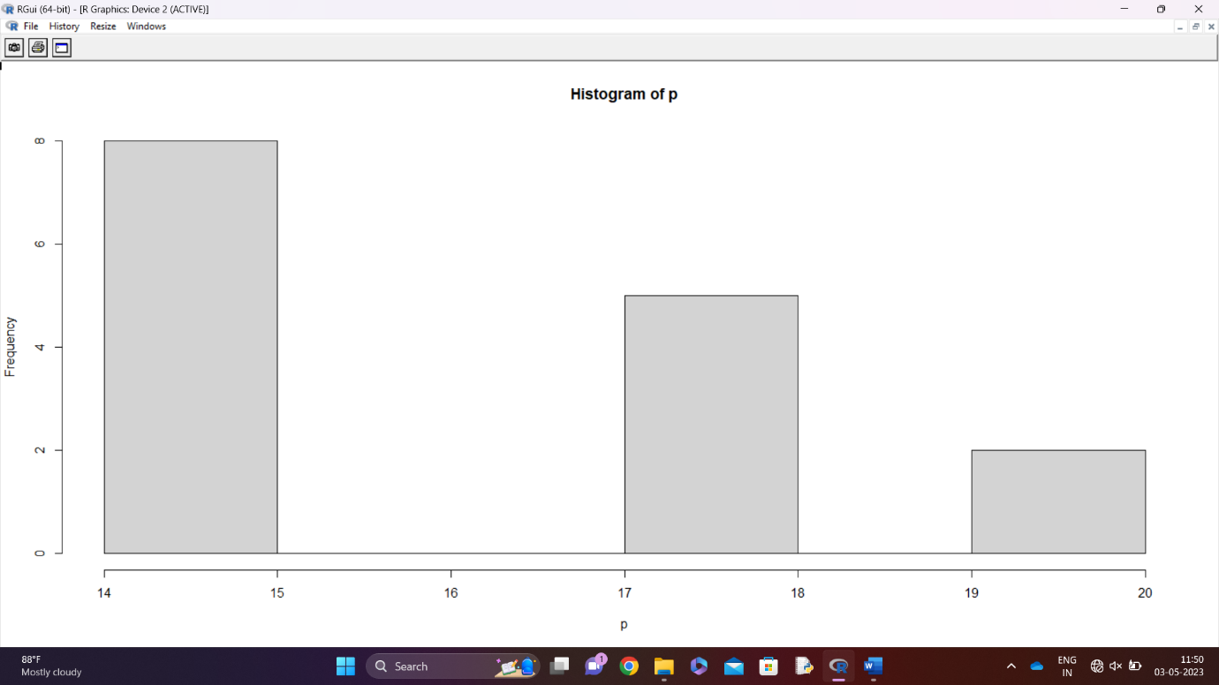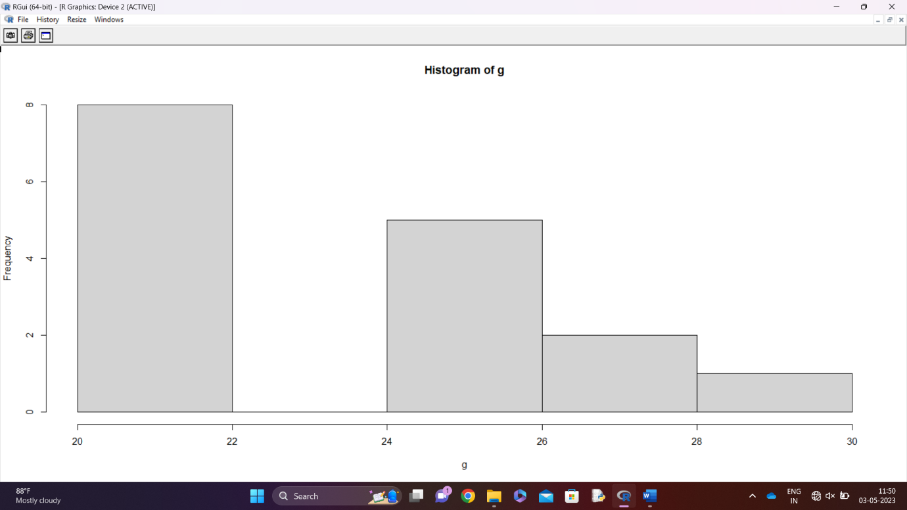

3)

ClassA=c(76,35,47,64,95,66,89,36,84,76,35,47,64,95,66,89,36,84)

ClassB=c(51,56,84,60,59,70,63,66,50,51,56,84,60,59,70,63,66,50)

i. Compare the highest mean,median and range.

ii. Boxplot

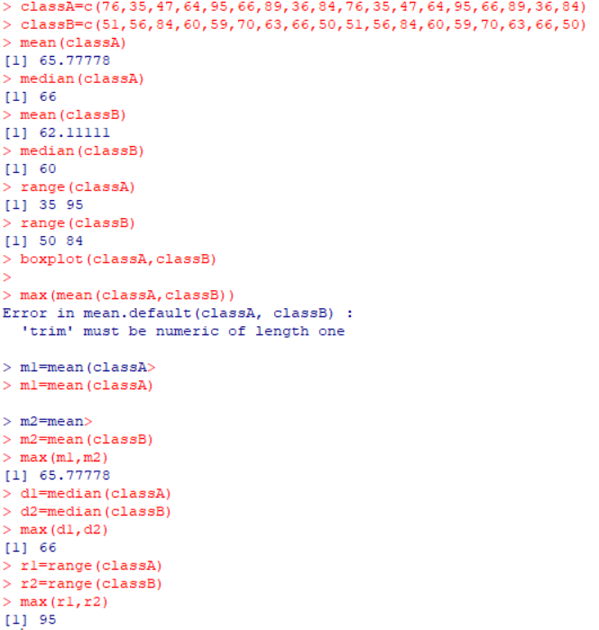

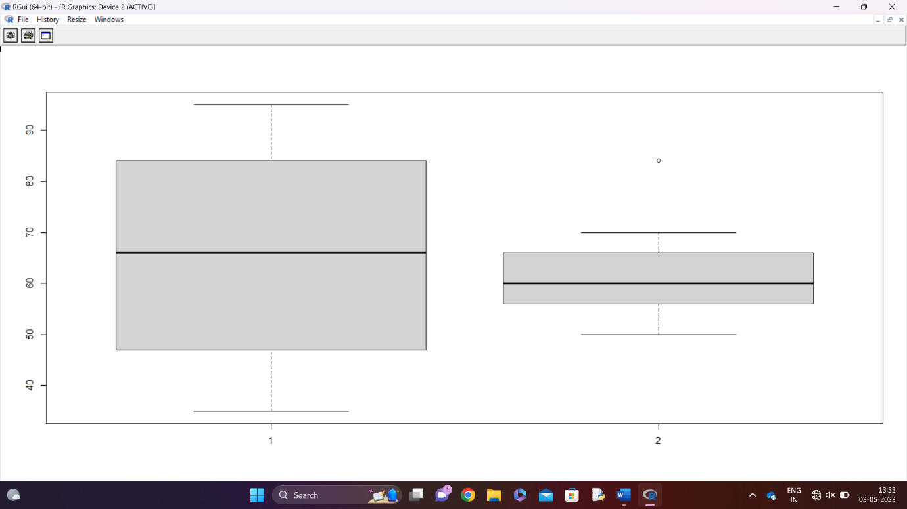

4.

i)Calculate the mean,median,standard deviations of age and percentage of fat.

ii)Draw the Boxplot.

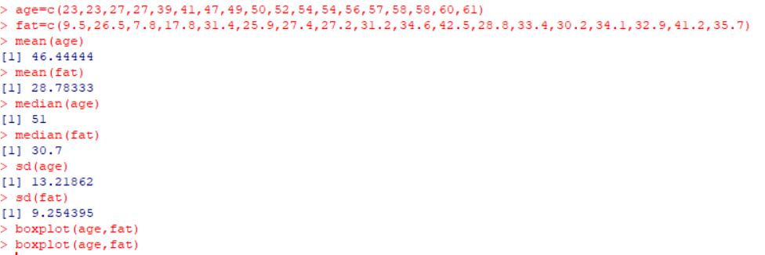

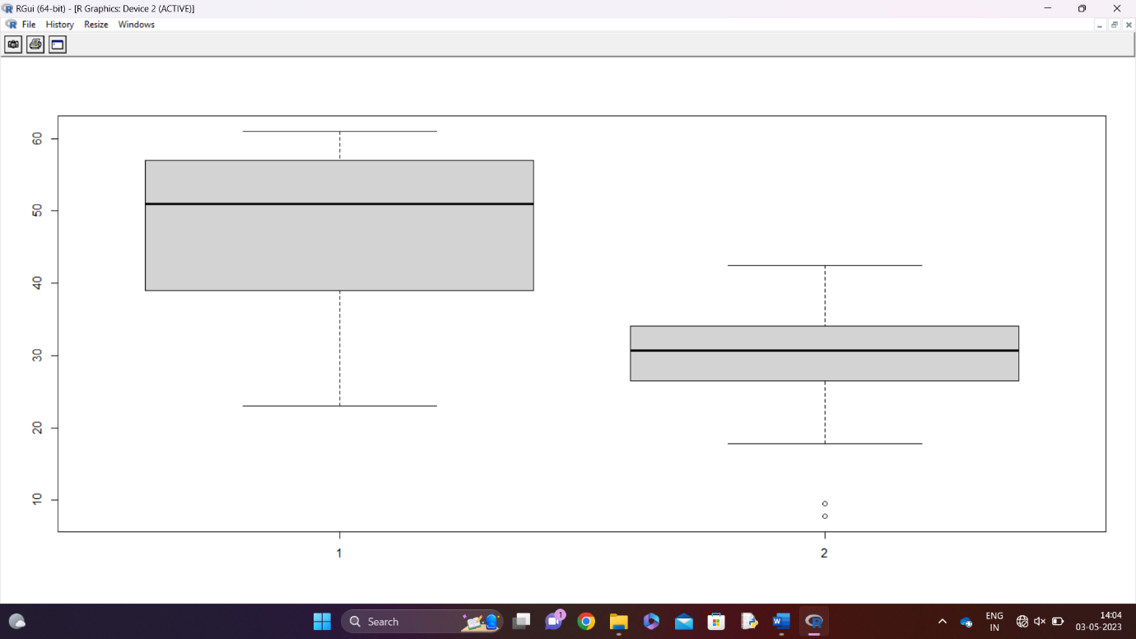

7.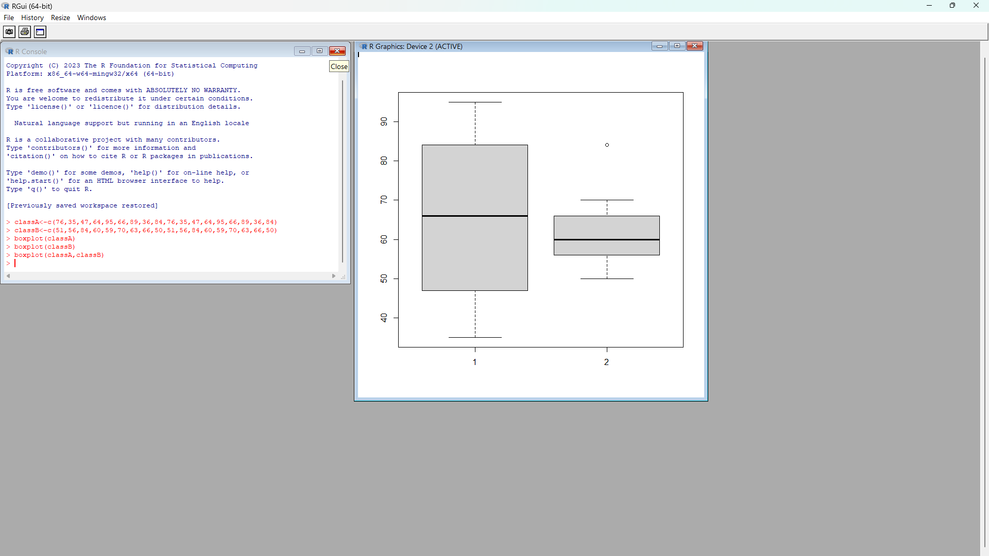

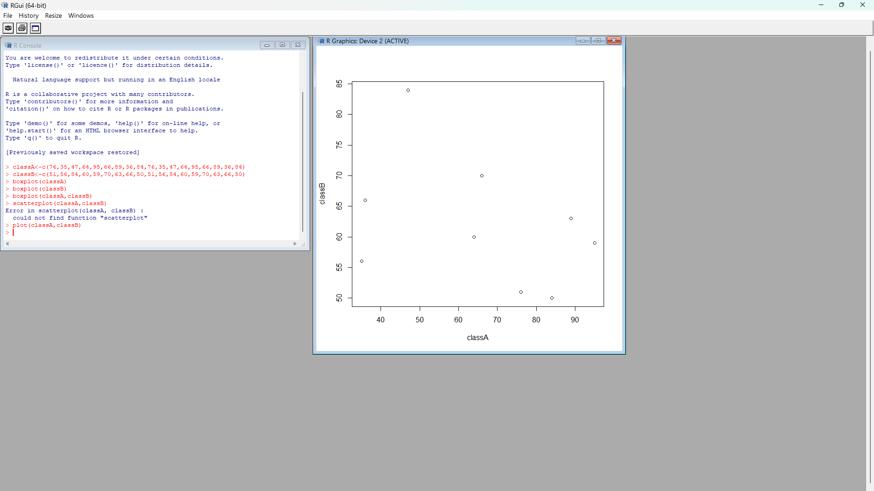

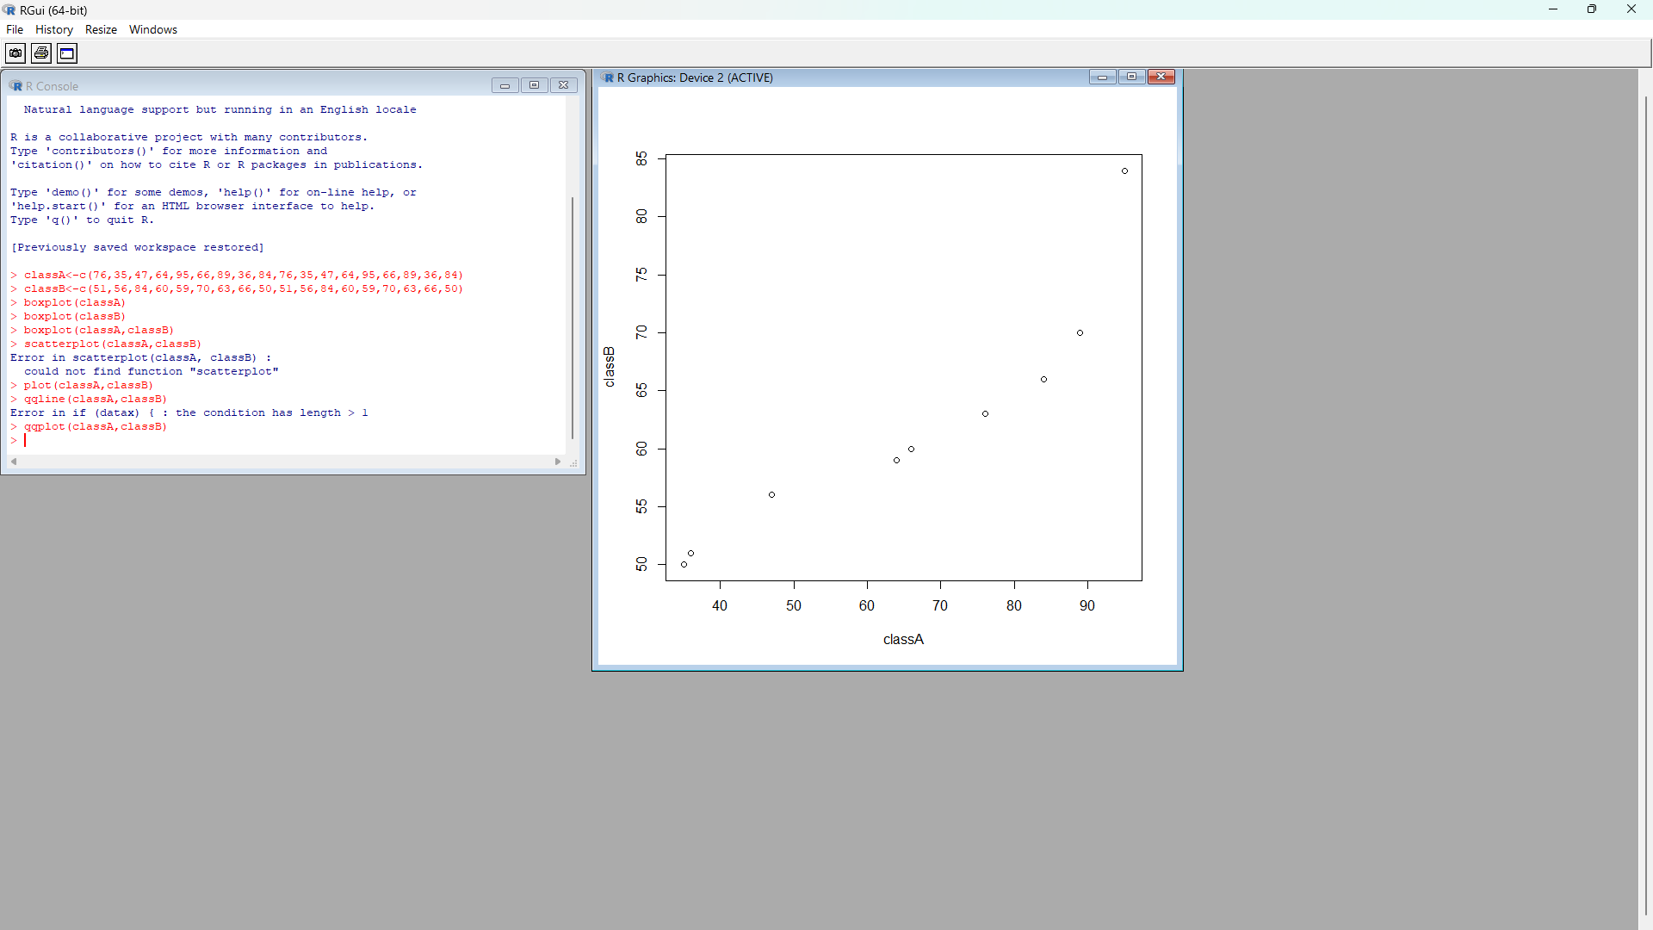

8.

